Task 8: Autonomous Steering

# UML Diagram

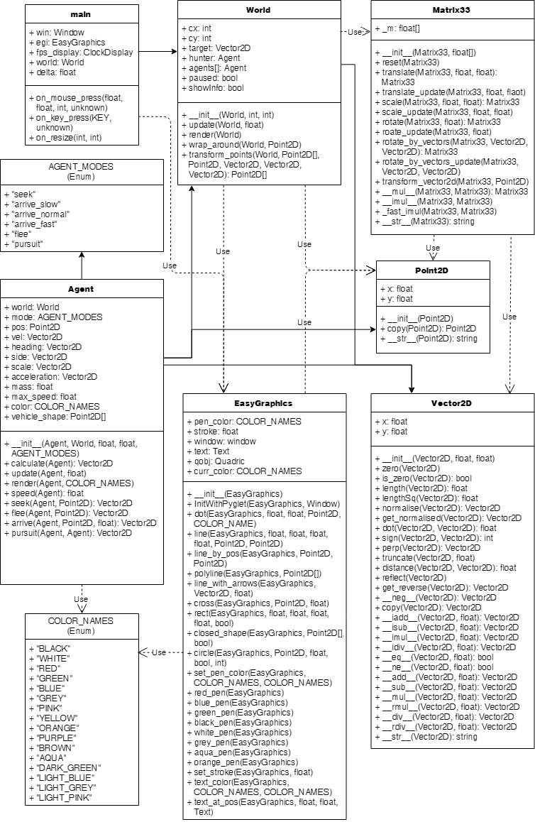

# Multiple Agents